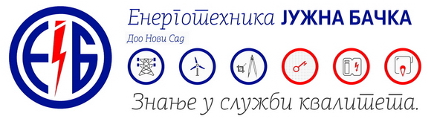

If you’re an electrical, mechanical and civil engineer, you like dynamic work, you’re communicative, ready to cooperate in a team and want to broaden your knowledge and work on projects in the field of electric power, thermal power or renewable sources, whether in a technical or commercial sector, send your CV to [konkurs@entjuba.rs](mailto:konkurs@entjuba.rs) and become part of our successful team!

**Job description and required qualifications for an engineer** (in the Electrical Engineering, Thermal Engineering or Civil Engineering Sector)

* Project management in the construction of power facilities (organizational, technological and financial aspects)
* Planning and organization of all resources for the project works
* Development of technical documentation
* Communication with internal and external customers during the project development
* Control, analysis and reporting during project execution
* Work experience in the same or similar jobs or an equivalent combination of knowledge and education is preferable
* Holding a license 450, 451 of the Serbian Chamber of Engineers is preferable
* Computer literacy - MS Office, AutoCad, MS-Project
* B category driving license
* Active use of English