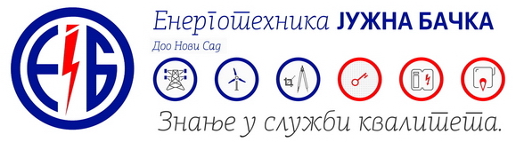

*Energotehnika - Južna Bačka has been ensuring for 5 decades that energy finds its way to the consumers. Our logo is the guarantee of quality in the field of electric engineering, thermal engineering and renewable energy sources, and our greatest value are our people and partnership with clients based on mutual trust and the desire that everything we build together would be to the satisfaction of the entire community. Energy moves the world, and we make it work!*

Become a part of our successful team and apply for the currently open position:

**METALWORKER - WELDER**

Place of work: Novi Sad

Number of employees: 2

**Job description**:

* Metalworks – mechanical and metalwork manufacture of equipment for electric power and thermal power plants
* Working in the workshop and, if necessary, on-site
* Work on heights, if necessary

**Required qualifications and skills:**

·         Skilled worker or high school education in mechanical/technical field

* Preferable experience in the same or similar jobs
* Welder certificate is preferable
* B category driving license

**Send your application until July 4, 2019.**

**Please note that only the shortlisted candidates will be invited.**