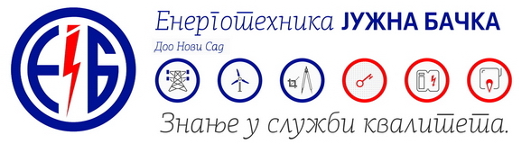

If you’re an electrical, mechanical and civil engineer, you like dynamic work, you’re communicative, ready to cooperate in a team and want to broaden your knowledge and work on projects in the field of electric power, thermal power or renewable sources, whether in a technical or commercial sector, send your CV to [konkurs@entjuba.rs](mailto:konkurs@entjuba.rs) and become part of our successful team!

**Job description and required qualifications for an engineer**

- Developing offers in the field of electrical power and the integration of the complete turnkey offers, all according to customer requirements

- Analysis of offers and contracting with customers

- Daily contact with clients, fieldwork if necessary, while considering the possibilities for selling the services on the market (communication/negotiations)

- Cooperation with other team members and reporting to the line manager

- Strong analytical, negotiation and communication skills

- Work experience in similar jobs is preferable

- Strong self-initiative and team spirit

- Computer literacy - MS Office, AutoCad, MS-Project

- B category driving license

- Knowledge of English is preferable